Lakhveer Kaur

Specified variables that I used to download the data

* Paradise/Sacramento: used the locagrid that intersects a point
* Daily Data
* Average of 10 priority models
* Rcp 8.5
* Precp: mm/day

A sneak peak of data:

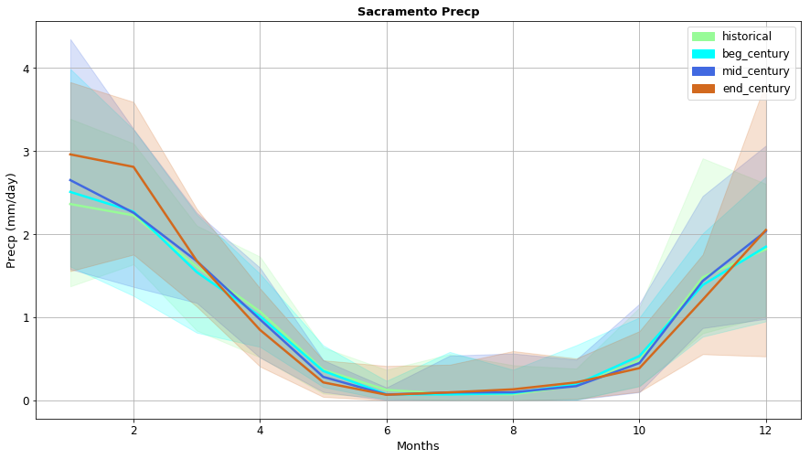

**Onset of Winter Precipitation and Wet-day frequency**

**Intro:** To represent the timing of onset of the winter precipitation season, we evaluate the number of days from Sep 30 needed to reach 10% of the fall (Oct-Dec) long-term mean precipitation total (historical).

We are going to keep only OCT, NOV, and DEC data (drop everything else)

To calculate the threshold:

* Aggregate the precipitation by year for historical time period (1961-1990)
* Take the average of aggregated precipitation data
* Calculate 10% of the average

To calculate number of Days needed to reach 10% of the fall long-term mean precipitation total:

* Reorganize the data by years in columns and month and date in rows.

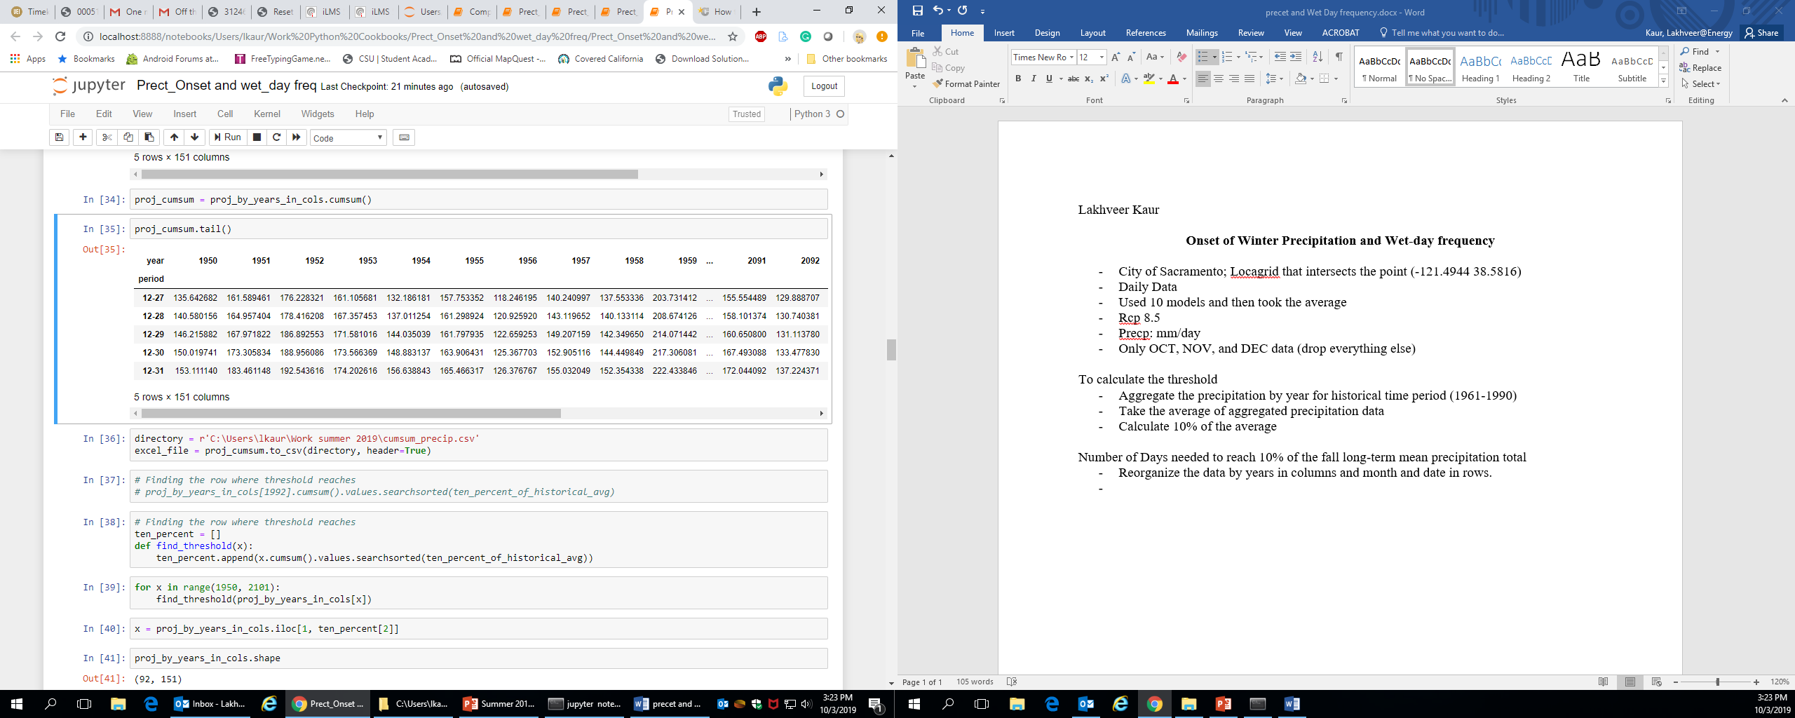

* Find the cumulative sum of every column
* Count the number of days per year that takes to reach the historical- threshold
* Find the day when threshold is reached every year and plot the graph

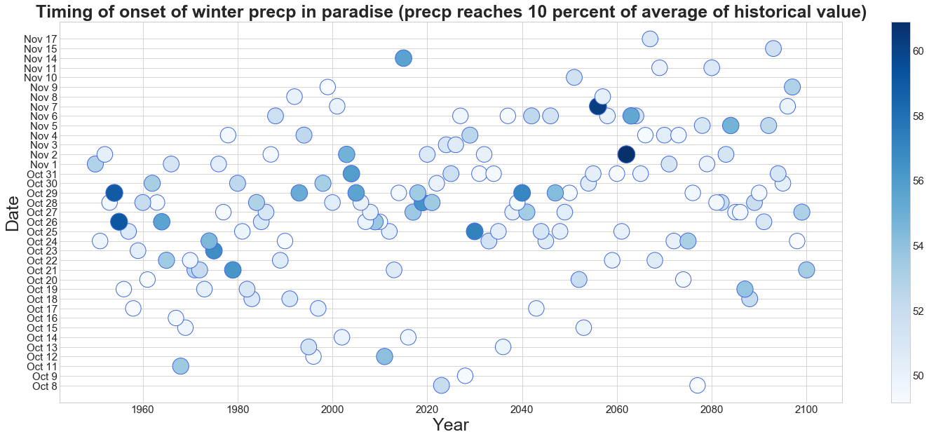

Graphs shows the day when Precipitation reaches 10 percent of average historical value. The color shows the total precipitation by that day

Water Year: Oct of previous year to September of current year.

* Aggregate the precipitation by year
* Find average and take the ten percent of the output
* Used two models separately
* CNRM-CM5 (Very wet in paradise)
* MIROC 5 (Driest of 4 priority models)

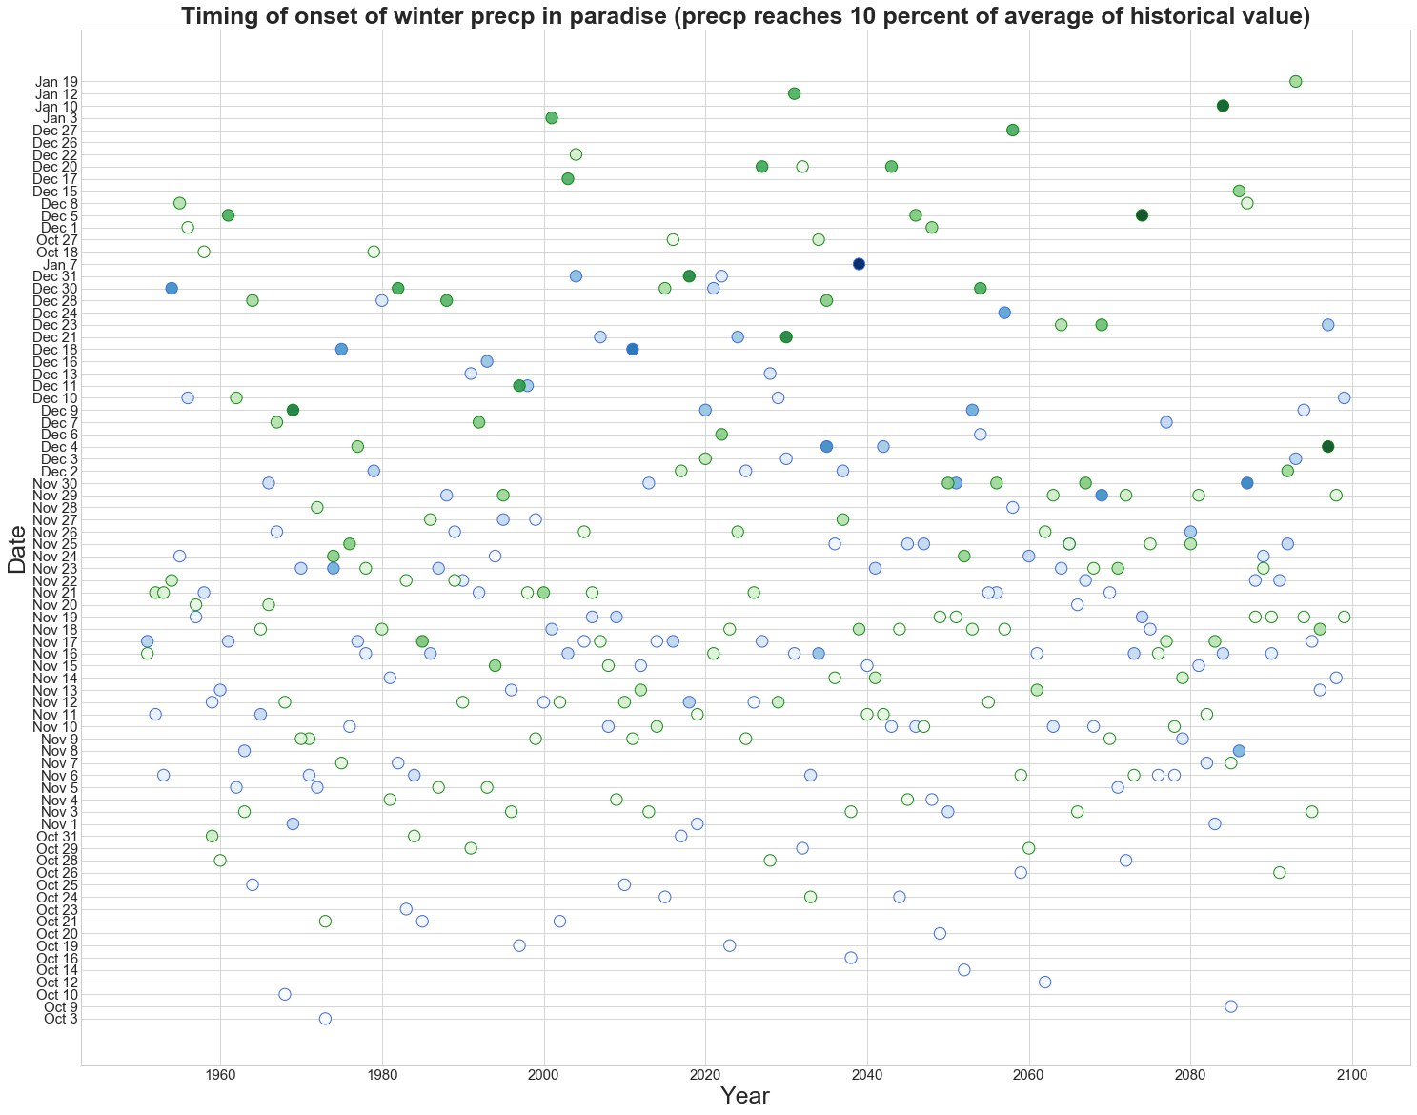

Blue: CanESM-CM5

Green: MIROC5

**WET DAY FREQUENCY**

**Definition:** Wet-Day frequency in Oct-Nov is defined as days when precipitation >= 2.54mm

* Trim the data to only Oct and Nov
* Get rid of all days when precipitation is lower than 2.54

